Subatomic Atlas - Initial Doc.:
This document describes the design of the Subatomic Internal Agentic-Based Chat Feature, a support tool to help onboard new team members (including Sales) and provide quick, accurate answers to investors. The feature leverages Retrieval-Augmented Generation (RAG), agentic chatbots, and integrations with enterprise data sources.

1) Vision and Purpose
- Onboarding Support: Enable new employees to quickly learn about Subatomic processes, products, and strategy.
- Investor Transparency: Provide domain-specific, validated answers for investor questions.
- Knowledge Accessibility: Centralize and surface insights across multiple data sources.

2) Key Features
- RAG-Based Search (Core Secret)
  - Queries are expanded, re-ranked, and matched against content.
  - Multi-source integration (Google Drive, internal docs, future CRM/Notion, etc.).
  - Dynamic vector compilation using ChromaDB for agile analysis.
- Agentic Chatbot Layer
  - Built upon Subatomic AI Starter Toolkit’s existing features.
  - Provides conversation management, reasoning, and agentic orchestration.
- Memory and Thread Management
  - Store chat histories in a dedicated DB.
  - Allow context continuity for multi-turn questions.
- n8n Integrations
  - Handle connections with Google Drive (Sam will maintain a dedicated onboarding folder).
  - Optionally extend to Slack, Notion, or other repositories.
- Reasoning Enhancements
  - Chain-of-Thought + Self-Consistency prompting for accuracy.
  - Abstracto tools for domain-specific reasoning beyond pure text retrieval.

3) Architecture Overview
The architecture follows the proven approach used for Vantage Financial and HeatTek agentic chatbots:
- Frontend: Chat UI with memory-aware threads.
- Backend:
  - RAG Engine: Query expansion, passage retrieval, vector re-ranking.
  - Vector DB: Local ChromaDB instances created on the fly.
  - Agent Layer: Orchestration of reasoning and tool use.
  - Integration Layer: n8n workflows for Google Drive and other data sources.
- Database: Store chat threads, vector indexes, and execution logs.

4) Process Flow
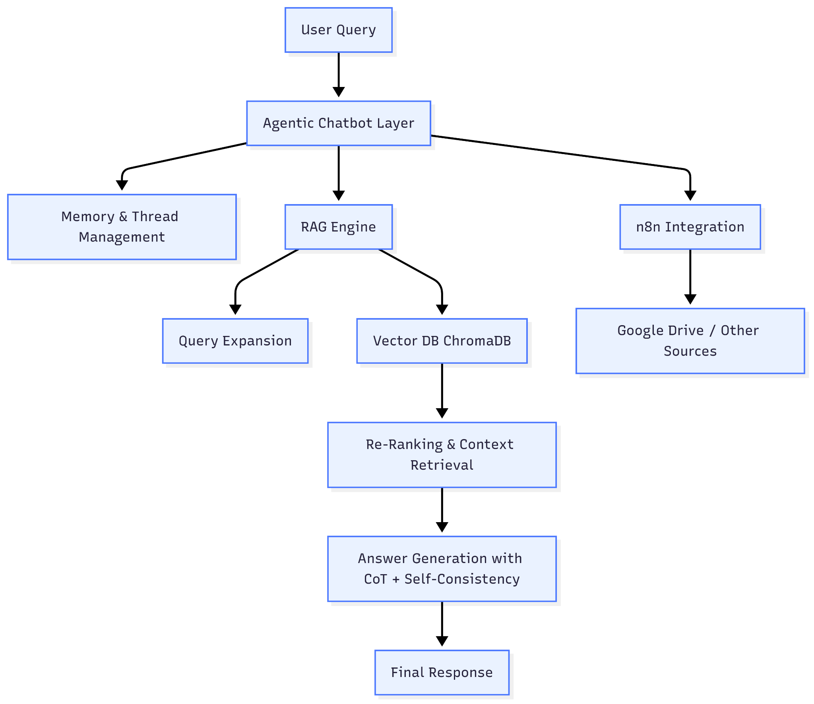

5) Core Principles
- Agility: On-the-fly vector compilation allows fast onboarding of new data.
- Reliability: Self-consistency ensures outputs are not generic but domain-grounded.
- Transparency: Chain-of-Thought and reasoning logs preserved for internal audit.
- Scalability: Easily extendable to new data sources through n8n connectors.

